Experiment 5.4
Analysis of Discrete-Time System
Aim:
To analyze the behavior of a discrete-time system by computing its response to an input
signal. This includes analyzing system properties such as stability, impulse response, and
system output for a given input.
Program:
% Analysis of Discrete-Time System
clc;
clear;
close all;
% Sample index
n = 0:20;
% Input sequence (Unit Step)
x = ones(1,length(n));
% System coefficients
b = [1];
a = [1 -0.5];
% System response
y = filter(b,a,x);
% Display output
disp('Output Sequence y(n):');
disp(y);
% Plotting
figure;
subplot(2,1,1);
stem(n,x,'filled');
grid on;
title('Input Signal x(n)');
xlabel('n');
ylabel('Amplitude');
subplot(2,1,2);
stem(n,y,'filled');
grid on;
title('Output Signal y(n)');
xlabel('n');
ylabel('Amplitude');

Output Waveform:
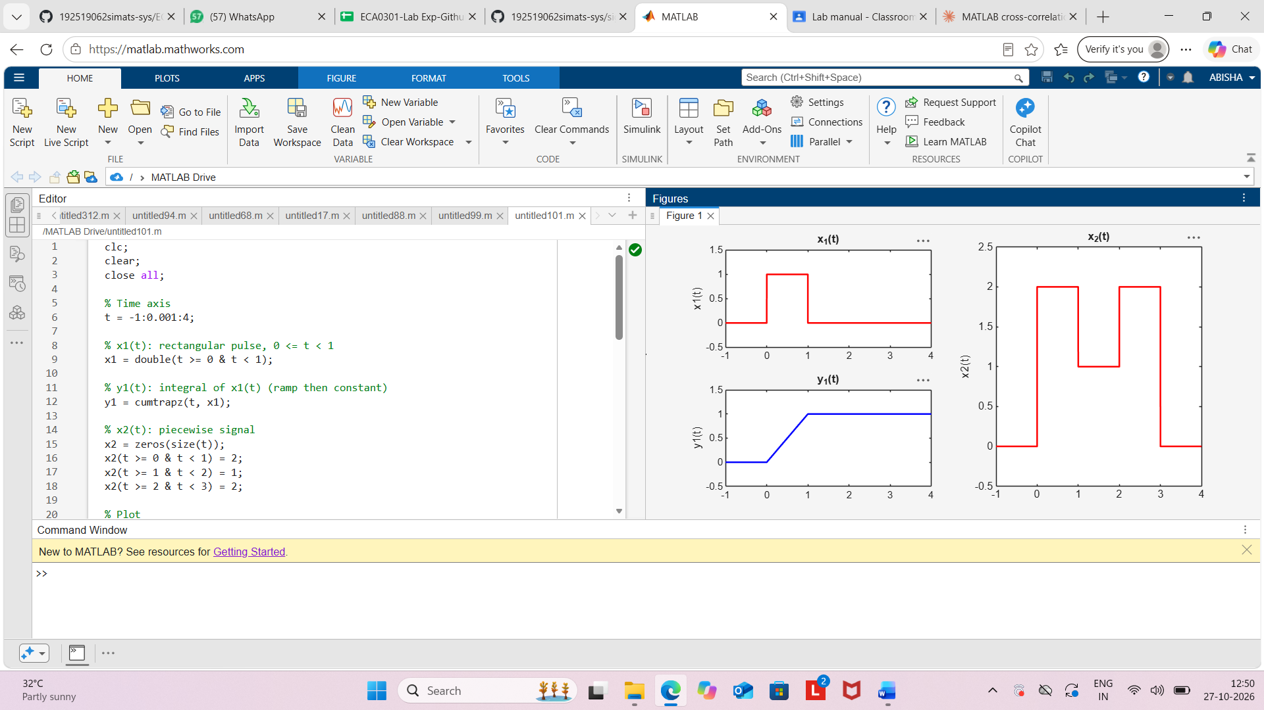

Result:
The discrete-time system described by the difference equation y(n)−0.5y(n−1)=x(n) was
analyzed using MATLAB. The output response to a unit step input was obtained and observed
to gradually approach the steady-state value of 2, confirming the stable behavior of the system.

